1. **He-Ne Laser**

**Objective:** To determine the wavelength of He-Ne laser source using diffraction grating

**Apparatus:**  He-Ne Laser Source, Diffraction grating with its mount, optical bench, a screen with millimeter scale.

**Theory:**

Diffraction is the bending of wave around an obstacle or small aperture whose size is comparable to the wavelength of light. If source and screen are far away from each other then Fraunhofer diffraction occurs.

A **plane diffraction grating** consists of an optically plane glass plate on which a number of equidistant lines are ruled. These lines divide the glass plate into opaque and transparent places, the width of which is of the order of the wavelength of visible light. The region where a line is drawn becomes opaque whereas the space between the two lines is transparent and acts as slit. These slits diffract the light waves there by producing a large number of beams which interfere in such a way to produce spectra. If a parallel beam of monochromatic light is incident normally on the plane transmission diffraction grating, bright diffraction maxima are observed on the other side of the grating. The diffraction maxima satisfies the grating condition : (a+b) sinθn = n λ where (a+b) is the grating element, ‘a’ is the separation between two slits and ‘b’ is the slit width. As d= (a+b),

d sinθn = n λ.

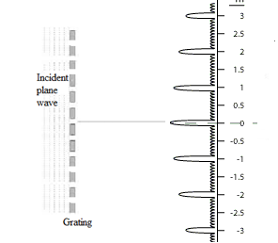

The term “**LASER**” is an acronym for **L**ight **A**mplification by **S**timulated **E**mission of **R**adiation. Laser light is spatially coherent, which means that the light emitted is narrow, low-divergence beam. Laser is highly monochromatic (with a narrow wavelength spectrum).

The gain medium of a laser is a material of controlled size, concentration and shape, amplifies the beam by the process of stimulated emission. It can be of any state: gas liquid or solid. The gain medium absorbs pump energy which raises some electrons into higher-energy level. When the number of particles in higher excited state exceeds that of lower state, population inversion is achieved. Atoms in excited state interact with photon resulting in stimulated emission. The light generated by stimulated emission is very similar to the input signal in terms of wavelength, phase and polarization. This gives laser light its characteristics coherence and often monochromaticity established by the optical cavity design. The optical cavity, a type of cavity resonator, contains reflectors which reflect the emitted light through the gain medium more than once before it is emitted from the output aperture.

He-Ne laser is a type gas laser. Its usual operation wavelength is 6328Å in the red portion of visible spectrum. It consists of a mixture of helium and neon gases in the ratio of about 10:1. When electric discharge is passed through it He atoms are more readily excitable than Neon as they are lighter. The The excited He atoms losses energy through collision with unexcited Ne atoms, Ne atoms are excited to the metastable states giving rise to stimulated emission.

**Working formula:**

If a parallel beam of monochromatic light is incident normally on the plane diffraction grating, maxima and minima occurs due to diffraction. The condition for diffraction maxima is:

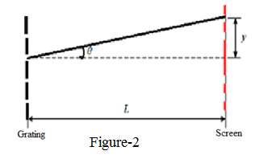d sinθn= n λ -------------------------------------(1)

Where d is known as grating element

θn is the angle of diffraction of the nth maximum

n is the order of spectrum

λ is the wavelength of the incident light

Again tanθ= y/L (according to Figure 1)

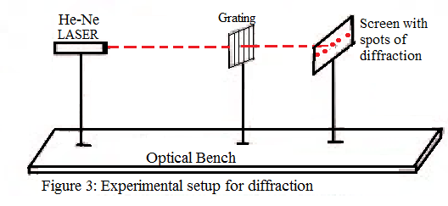Hence sinθ = $\frac{y}{\sqrt{y^{2}+L^{2}}}$-------------(2)

Using equation (2) in equation (1)

d $\frac{y}{\sqrt{y^{2}+L^{2}}}$ = nλ

Hence λ = $\frac{d y}{n \sqrt{y^{2}+L^{2}}}$

**d= 1/N**

**N= number of slits/ cm**

**Procedure:**

1. Fix the laser source, grating and screen so that they are in one line.
2. Switch on the laser source so that it falls at the centre of the grating.
3. Adjust the distance between the slit and screen so that the diffracted sharp and bright light spots produces at the centre of the screen.
4. The brightest spot is the central maxima and other spots are symmetrically situated on both the sides of the central maxima with diminishing intensities.
5. Measure the distance between the central maxima and first maxima on the screen, this distance will correspond to first maxima (n=1).
6. Similarly, measure the distance of second maxima (n=2), and third maxima (n=3).
7. Note the distance between slit and screen (L).

**Observations:**

Number of lines per millimeter on the grating, N= 3000 / cm

Grating element, d = $\frac{1}{N}$ = 1/3000 cm

|  |  |  |  |  |  |  |  |
| --- | --- | --- | --- | --- | --- | --- | --- |
| Sr. No. | Distance between grating and screen, L (cm) | Order of maxima  (n) | Distance of maxima from center | | | λ = $\frac{d y}{n \sqrt{y^{2}+L^{2}}}$ (Å) | λ mean (Å) |
| On Left Side, y1  (cm) | On Right Side, y2 (cm) | Mean, y=(y1+y2)/2  (cm) |
| 1. | 16 | 1 | 5.5 | 5.6 |  |  |  |
| 2. | 10 | 1 | 3.4 | 3.5 |  |  |
| 3. | 10 | 2 | 8.5 | 8.3 |  |  |
| 4. | 7 | 1 | 2.4 | 2.3 |  |  |
| 5. | 7 | 2 | 6.2 | 6..0 |  |  |
| 6. | 4 | 1 | 1.5 | 1.7 |  |  |

**Calculations:**

**λ = $\frac{d y}{n \sqrt{y^{2}+L^{2}}}$**

Calculate λ for all readings and find mean λ

**λmean = = ....... (Å)**

**Result:**

The wavelength of given laser source, λ= ......................Å

The standard value of He-Ne laser source is 6328Å.

**Percentage error:**

% Error = [(Standard value-Experimental value) x100]/Standard value

**= $\frac{λmean-6328}{6328} ×100= ……..\%$**

**Sources of Error and Precautions:**

1. Never look directly into the laser source
2. Grating should not be touched by fingers.
3. Grating should be set normal to the incident light.

N slits = 1 cm

1slit =1cm/N

d=1cm/N